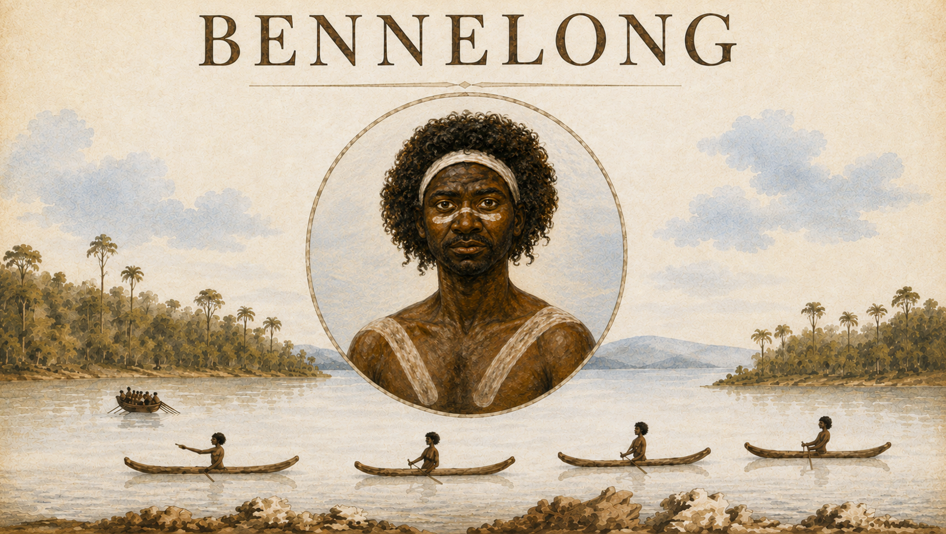 VIDEO TRANSCRIPT
The remarkable life of Woollarawarre Benelong
Long before Sydney was a city, Aboriginal people had lived around Sydney Harbour for thousands of years.
They belonged to different clans, spoke their own languages and had deep connections to Country.
One of these people was a man named Woollarawarre Bennelong.
He was born around 1764 and was a Wangal man of the Eora.
When Bennelong was in his twenties, his world changed dramatically.
In January 1788, British ships sailed into Sydney Harbour.
Governor Arthur Phillip and the First Fleet established a British settlement at Sydney Cove.
But the land was already home to Aboriginal people.
At first, Governor Phillip struggled to communicate with the Aboriginal people.
He wanted someone who could teach the Aboriginal language and culture — and who could learn English.
But instead of waiting for someone to come willingly, Phillip made a troubling decision.
He ordered his men to capture Aboriginal people.
In November 1789, British officers captured two men – one was named Colebee, the other was Bennelong.
They were taken to the British settlement and kept there against their will.
While he was being held, Bennelong began teaching the British some words from his language.
Governor Phillip spent time with him, trying to learn about Aboriginal life and customs.
But after several months, Bennelong escaped.
He returned to his people and to Aboriginal life around the harbour.
Over time, he began visiting Sydney Cove again.
Bennelong could move between the Aboriginal world and the new British settlement.
But he remained connected to his own people, customs and responsibilities.
Bennelong asked Governor Phillip for a place where he could stay near the settlement.
A small brick hut was built for him on a rocky point on Sydney Harbour.
In December 1792, Governor Phillip left New South Wales and sailed back to Britain.
And Bennelong and another Aboriginal man, Yemmerawanne, went with him.
A British account written at the time said the two men went "voluntarily and cheerfully."
Their families, however, were deeply upset to see them leave.
Bennelong and Yemmerawanne sailed thousands of kilometres across the world.
After a voyage of about six months, they reached England in May 1793.
Imagine how different England must have seemed.
Huge cities.
Crowded streets.
Stone buildings.
Cold weather.
And thousands upon thousands of people.
On their first day in London Bennelong and Yemmerrawanne were measured for clothes in the latest fashion.
They toured the sights, including St Paul’s Cathedral and the Royal Menagerie - or zoo - at the Tower of London, and saw plays, operas and a circus.
Bennelong and Yemmerawanne attracted enormous attention.
They met British people from very different parts of society and experienced a world unlike anything they had known in Sydney.
But life in England was not simply an exciting adventure.
Both men became ill.
We can discover clues about their experience from newspapers written at the time.
In September 1793, a London newspaper reported that Bennelong and Yemmerawanne had become very unwell. It said they could not walk without sticks, that one had become very thin, and that they seemed “constantly dejected”.
Sadly, Yemmerawanne died in England in 1794.
Bennelong was now far from his family, his Country and everything familiar to him.
Eventually, he began the long journey home.
In 1795, Bennelong returned to Sydney.
He had travelled from one side of the world to the other — and back again.
For a time, he continued to spend time with British colonists.
But he also returned to Aboriginal life.
Newspapers later criticised him because he did not give up his Aboriginal way of life.
Following his death in January 1813, one writer complained that Bennelong had returned to the bush after living with Europeans.
But today we can ask a different question.
Why should Bennelong have been expected to stop being Aboriginal?
Bennelong is sometimes described simply as an interpreter or a friend of Governor Phillip.
But his story is much bigger than that.
He was a Wangal man with his own family, culture, relationships and responsibilities.
He survived enormous changes to his Country.
He learned about the newcomers.
He travelled halfway around the world.
And he helped Aboriginal people and British colonists understand something of each other's worlds.
More than two hundred years later, Bennelong's name remains part of Sydney.
That humble hut that was built for him so long ago has been replaced many times over.
Today it is the site of one of Australia's most famous landmarks, built on the point that bears his name.

