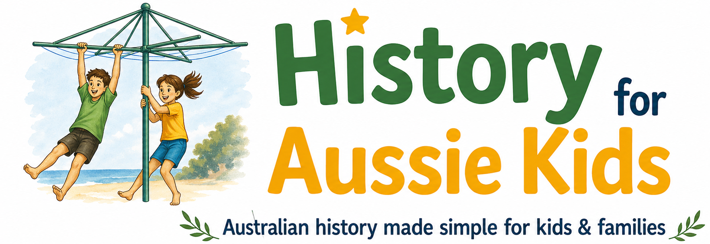
31 July 2026
Hello and welcome to my newsletter 🙂
Things are evolving quickly as we move towards 2027 and the introduction of the new NSW curriculum. It is aligned with the Australian Curriculum Version 9.0, which has now been adopted, or adapted, by most other Australian states and territories. I am developing resources aligned with the NSW curriculum in the first instance, but if you have a particular history topic or question you'd like to see covered, please let me know.
This newsletter is designed to complement the History for Aussie Kids content by sharing details that don't always make it into resources created for children.
Rowdy convict women
As I write, I am researching the experiences of women on the First Fleet. Based on the primary sources, they really were a rowdy bunch!
The fleet spent around two months delayed in Portsmouth Harbour before finally setting sail, and it became a bit too much for women on one of the ships, who broke through the bulkhead into the sailors' quarters, resulting in a few unexpected arrivals nine months later! The women also persuaded many sailors to spend their wages on them at the fleet's various ports of call — I suspect those transactions weren't acts of pure generosity!
So, if you wonder how these pregnancies happened while at sea, now you have an idea.
Another discovery relates to punishment. On some ships, women were initially flogged over their petticoats or breeches, rather than on their backs. But some captains stopped flogging women altogether because it caused embarrassment during menstruation.
Aboriginal content and authenticity
I am continuing my efforts to ensure cultural authenticity with the Aboriginal content. I will be attending the 2026 TIPIAC × Riley Callie Resources National First Nations Education Conference in Brisbane on 14 August, with a view to sharing what I learn and incorporating this into future resources.
I'm also currently speaking with several Aboriginal artists to commission artwork and other creative contributions. If you know of any Aboriginal artists – including students - who may be interested in collaborating and expressing their culture, I'd love to hear from you/them.
Until next time,
Michelle Hoctor
History for Aussie Kids

