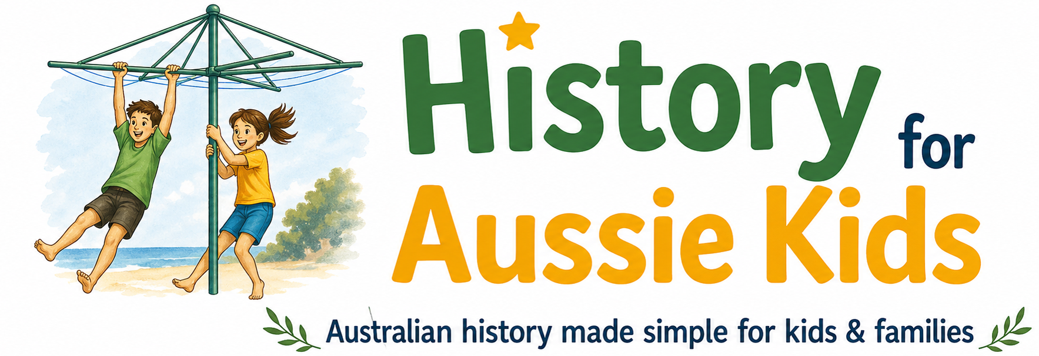
10 September 2026
Hello and welcome to our latest newsletter
History for Aussie Kids has a brand-new Facebook page!
Exciting news! You can now follow History for Aussie Kids on Facebook for Australian history stories, new videos, teaching resources and updates — plus plenty of fascinating snippets from the past and opportunities to join the history conversation.
Join us on Facebook → History for Aussie Kids on Facebook
Six new videos
Since our last newsletter, six new videos have been added to the History for Aussie Kids YouTube channel — all aligned with the 2027 HSIE syllabus.
Stage 2
· What was it like to be a child on the First Fleet?
· The life of First Fleet convict Elizabeth 'Betty' Thackery
· Woollarawarre Bennelong, Aboriginal man of the Eora
· How European explorers misunderstood Aboriginal Australia
· Aboriginal Australians and the Macassan trade + Djaladjari’s journey
Early Stage 1
· The Emu in the Sky - A Wiradjuri Dreaming Story

Coming next: Resources transported on the First Fleet – Stage 2.
Did you know that 747,000 nails were transported on the First Fleet? We’re researching the supplies, equipment, livestock and other resources transported on the First Fleet, including those collected at stops along the way. There’s a surprising amount to uncover — including some very different accounts of what was taken and why.
All videos are free to use in the classroom. You’ll also find accompanying resources on the History for Aussie Kids website, including historical research and links to primary and secondary sources to support further learning.
At this stage, the resources focus on providing the research and source material rather than prescribed answers, allowing students to examine the evidence and form their own critical assessment of the different sources and perspectives.
Especially for Stage 2, a variety of sources have been provided for each topic, with the research available in Word document downloads.
Due to popular demand, we are also preparing video transcripts, which will be available on the website. Some are available in the notes section of the video, where character limits permit.
Website updates
Some housekeeping has been underway to iron out any website glitches (apologies if you've struck any issues). Much of this work has focused on streamlining the Stage 2 resources, to make them as accessible as possible.
General progress report
Work is progressing through the Stage 2 resources, with new research and content being added. Once Stage 2 is complete, we’ll turn our attention to researching and developing resources for Stage 3.
There’s plenty more Australian history to come!

Until next time,
Michelle & Elizabeth Hoctor
History for Aussie Kids
